
RAMAIAH
Institute of Technology
USN | 1 | M | S

(Autonomous Institute, Affiliated to VTU)
(Approved by AICTE, New Delhi & Govt. of Karnataka) Accredited by NBA & NAAC with ‘A’ Grade

SEMESTER END EXAMINATIONS – JUNE 2019

Course & Branch | : | B.E. : Electrical and Electronics Engg | Semester | : | VI
Subject | : | Power Systems – I | Max. Marks | : | 100
Subject Code | : | EE61 | Duration | : | 3 Hrs

Instructions to the Candidates:
- Answer one full question from each unit.

 |  | UNIT- I
1. | a) | Define per unit quantity? What are the advantages of per unit system? | CO2 | (06)
 | b) | Show that per unit impedance of a transformer is same irrespective of the side of which it is calculated. | CO2 | (07)
 | c) | A 120MVA, 19.5kV generator has a synchronous reactance of 0.15pu and it is connected to transmission through a transformer rated 150MVA, 230/18kV (star/delta) with X=0.1pu.  - Calculate the per unit reactance by taking generator rating as base values.  - Calculate the per unit reactance by taking transformer rating as base values.  - Calculate the per unit reactance for a base value of 100MVA, and 220kV on HV side of transformer. | CO3 | (07)
2. | a) | What is one line diagram of a power system? With typical example explain its significance. | CO1 | (07)
 | b) | A synchronous generator and motor are rated for 20MVA, 11kV and both have sub-transient reactance of 15%. The line connecting them has a reactance of 20% on the base of machine rating. The motor is drawing 15MW at 0.8pf lagging. The terminal voltage of the motor is 10.8kV. When a symmetrical three phase fault occurs at motor terminals, calculate the sub-transient current in generator, motor and at the fault point. | CO3 | (13)
 |  | UNIT-II
3. | a) | The current flowing to a delta connected load through line ‘a’ is 10A. With the current in line ‘a’ as reference and assuming that line c is open, find the symmetrical components of line currents. | CO4 | (08)
 | b) | Why is there a need for symmetrical components transformation? Derive the phase relationship between the delta sequence currents and the line sequence currents. | CO4 | (08)
 | c) | A Y-Δ, 3-phase transformer bank is formed using three numbers of 1-phase transformers each rated at 300kVA, 127/13.2 kV. What is the kVA and kV rating of the 3-phase bank? | CO4 | (04)
4. | a) | The line to neutral voltages in a 3-phase system are V_{an}=2000°V, V_{bn}=200100°V, and V_{cn}=400270°V. Find the symmetrical components of the voltages. | CO4 | (08)
 | b) | In a 3-phase system, with a base of 80 MVA, the sequence voltages are Va₁ = (1+j0)p.u, Va₂ = (0.4+j0.3)p.u and Va₀ = (0.1+j0.1) p.u. The sequence currents are Ia₁ = (0.8-j0.6)p.u, Ia₂ = (0.2-j0.1)p.u and Ia₀ = (0.05-j0.08)p.u. Find the three phase power in MW and MVAR. | CO4 | (04)
 | c) | What are symmetrical components? Prove that the zero-sequence component depends on the neutral current. | CO4 | (08)
 |  | UNIT- III
5. | a) | Draw the positive, negative and zero sequence networks of the power system shown in Fig.5(a).  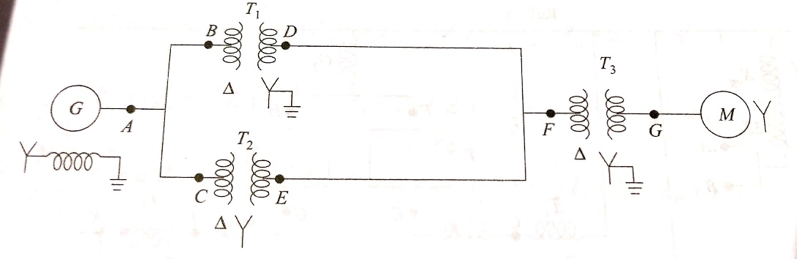  Fig.5(a) | CO4 | (05)
 | b) | A three phase unbalanced source has the following line-to-neutral voltage. V_{a} =10025°V, V_{b} =50-155°V and V_{c} =40100°V. it is supplied to a star connected load with a series impedance of (4+j12)Ω per phase and mutual impedance of j2Ω. The neutral of source and load are grounded. Determine the load phase currents using symmetrical components. | CO4 | (08)
 | c) | Obtain the sequence impedances of transmission line. Why is the zero reactance is higher in case of transmission line? | CO4 | (07)
6. | a) | Show that sequence current produces respective sequence voltage drops only. | CO4 | (06)
 | b) | Draw the sequence networks for the network shown in Fig.6 (b). Mark all reactances in p.u on a base of 50MVA, 13.8kV in circuit of generator 1. The neutrals of generator 1 and 3 are connected to ground through reactors having a reactance of 6%, on the machine base. Each generator has negative sequence reactance of 20% and zero sequence reactance of 5% on its own rating. The zero sequence reactances of the transmission lines are 2.5 times the positive sequence reactance.  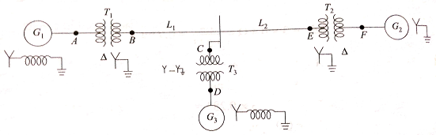  Fig.6(b)  G₁: 20 MVA, 13.8 kV, X_{d}’’=0.2 pu; G₂: 30 MVA, 20 kV, X_{d}’’=0.2 pu  G₃: 30 MVA, 20 kV, X_{d}’’=0.2 pu; T₁: 25 MVA, 220Y/13.8Δ kV, X=10%  T₂: Single phase units, each rated 10 MVA, 132/22 kV, X = 10%  T₃: 35 MVA, 220Y/22Y kV, X=10%; X_{L1} = 80Ω; X_{L2} = 100Ω | CO4 | (14)
 |  | UNIT- IV
7. | a) | Draw and explain the interconnection of sequence networks in case of i) line to ground fault ii) double line to ground fault. | CO4 | (12)
 | b) | A salient pole generator rated 20MVA, 13.8kV, with X₁= 0.25pu, X₂= 0.35pu and X₀=0.1pu. The neutral of the generator is solidly grounded. Determine the sub-transient current in the generator and the line to line voltages for sub-transient condition when an L-G fault occurs at the generator terminal with the generator operating at rated voltage. Neglect resistance. | CO4 | (08)
8. | a) | The reactances of a generator rated 100MVA, 20kV, are X_{d}”=X₁=X₂=20% and X₀=5%. The generator is connected to a Δ-Y transformer rated 100MVA, 20Δ-230Y kV, with a reactance of 10%. The neutral of the transformer is solidly grounded. The terminal voltage of the generator is 20kV when a single line-to-ground fault occurs on the open circuited, high voltage side of the transformer. Find the initial symmetrical rms current in all phases of the generator. | CO4 | (10)
 | b) | Derive the expression for the fault current in case of an L-G fault on an unloaded generator through a fault impedance. | CO4 | (10)
 |  | UNIT- V
9. | a) | Explain power angle equation. | CO5 | (08)
 | b) | Define critical clearing angle and critical clearing time. A 60-Hz generator is supplying 60% of P_{max} to an infinite bus through a reactive network. A fault occurs which increases the reactance of the network between the generator terminal voltage and the infinite bus by 400%. When the fault is cleared the maximum power that can be delivered is 80% of the original maximum value. Determine the critical clearing angle for the condition described. | CO5 | (12)
10 | a) | Explain equal area criterion of stability. Mention its applications. | CO5 | (10)
 | b) | Write short notes on: i)swing equation ii) SSSL and TSL. | CO5 | (10)

****************

